

**OM INFORMATION SYSTEM**

**QR CODE ORDER PROJECT**

**Intern Project**

Mert KAHRAMANTÜRK

18030451002

MIS

Contents

1.OM INFORMATION TECHNOLOGY 3

*1.1**Key Business Factors* 3

2. Our company's Mission, Goals, and Objectives 4

*2.1**OM Information Technology* 4

3.QR Information System Process 5

*3.1**Preliminary Process Flow Diagram* 5

*3.2**Information Flow Diagram* 6

4.Utility Test 7

*4.1**Old System Cycle Time* 8

*4.2**New System Cycle Time* 8

# OM INFORMATION TECHNOLOGY

## Key Business Factors

Forget all the third generation coffee shops you go to. Tablets are available on every table. With this tablet, the customer creates his own coffee with rich options. Coffee bean selection (Guatemala, Mexico, Uganda, India, Honduras, Ethiopia, Colombia, Vietnam ..) Coffee flavor selection (Hazelnut, chocolate, caramel, almond, vanilla, coconut ...) Milk cream density (Dense, medium, small.) By choosing the options of glass size (large, medium, small), the customer creates his own coffee completely according to the taste. We will take our place in the market with a concept that cannot be given up by those who say I am a coffee gourmet. Our coffee shop will have a vintage design with two floors. On the second floor, a lecture and business area will be created with a chill music for customers. Downstairs, we will host our customers who want to chat and spend time with their friends.

We will offer our customers a unique coffee experience together with specially designed desserts for our coffee shop. The customer selected and customized their products using the tablets on their desk. He completed and confirmed his order. Thus, our customer completed his order with the revisions he wanted without leaving his desk and without interrupting their conversations. What about paying? Will he have to come to the cash register like the old style coffee shops? No. After the order is completed, the square code screen will open and the customer will allow the customer to pay online just by holding his phone.

With this concept, the customer will be able to order and pay without having to interrupt the business and friend chat. With this concept, customers will not be able to postpone their orders due to the problem of waiting queues and will receive the service they want comfortably. Market researchers expected for fourth generation coffee people growth own coffee bean to home. İt's very utopian idea. Why don't be fourth generation is easier access and build own coffee?

# Our company's Mission, Goals, and Objectives

## OM Information Technology

Our company aims to carry its business partners to the leading positions of the sector with its information systems development and change studies. With the innovative business models developed in this context, we are working to keep the profits of our partners at the maximum level and to minimize the operating expenses. Our company has adopted the AGILE method working principle, and in this context, it is aimed to provide the best result for you by communicating dynamically with you, our business partners and developers throughout the process.

We are aware that speed is one of the most important factors in today's world. In this context, it is one of our basic principles to provide you with the best service in the fastest way.

It is aimed that you will adapt to the changes that may occur in the future in the sector as quickly as possible by creating a flexibility in the information systems we have built. As it is known, companies that cannot keep up with the changes in the sector lose their influence and fall behind from the market. For this reason, we aim for you, our business partners, to maintain our position in the long term as well as the short term.

# QR Information System Process

## Preliminary Process Flow Diagram

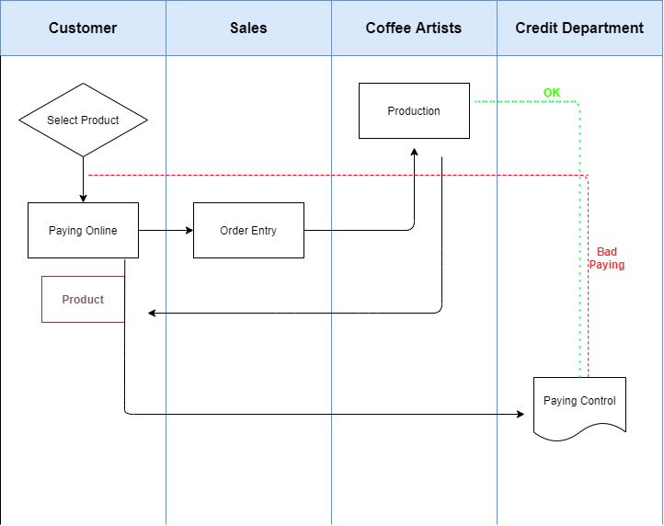

* The customer places his order on the tablet at his desk and makes his payment online. Payment confirmation check is made. If the payment is successful, the order reaches our coffee artists and is delivered to the client's table. If the payment is unsuccessful, feedback will be given to the customer. You are given the option to try again or get support from the staff.

## Information Flow Diagram

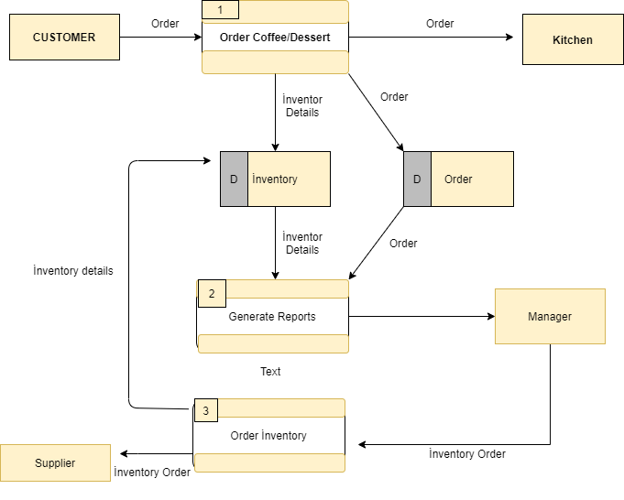

* The order from the customer is sent to the system via the tablet. After the stock control, the order is transferred to the kitchen. Products that are running low in stock are notified directly to the manager and reported to the supplier.

In the new operation system we are transitioning to, our customers can place their orders with the tablet on their table without any intermediaries and they are directly transmitted to our bar. Firstly, we see a serious shortening in our production cycle time. We made the following calculations with the data we received from our old and new operation systems.

# Utility Test

## Old System Cycle Time

$$\text{Maximum }\text{output}=\frac{\text{available time}}{\text{bottleneck} \text{task}\text{ time}}=\frac{\text{960 min./hr.}}{\text{5 min./unit}}=\text{192 units/hr,or coffe per hour}$$

## New System Cycle Time

$$\text{Maximum }\text{output}=\frac{\text{available time}}{\text{bottleneck} \text{task}\text{ time}}=\frac{\text{960 min./hr.}}{\text{2 min./unit}}=\text{480 units/hr,or coffe per hour}$$

As seen in the above data, we realized that the most time consuming part of our coffee production line is the order taking and forwarding to the bar.

Secondly, the number of workers we had to work with this BPA (Business Process Automation) system decreased. Thus, we had the opportunity to offer lower prices compared to other companies with the savings we made on workers' wages. Although we expanded our product range with the innovative order system we made, this did not increase our cost per unit. Also, with the variety we make in coffee beans, our flexibility in volume has increased. Thus, by reacting immediately to the increasing density and low demand, our customer satisfaction has always been on top.

Third, there has been a significant increase in our service quality with the change in our operating system. Confusion in orders was eliminated with our customers automatically placing their orders via the tablet at their tables. In addition, the shortening of the order time cycle was reflected in our business as customer satisfaction. Our company is aware of the importance of the speed of delivery with its flexible attitude towards the changes in our age. People now care more about fast access than price. Self-service businesses (Starbucks, Arabica..) aim to provide higher quality service cheaper by saving on the number of employees, but people give more importance to getting service without interrupting their work or conversation. With the system we have built, our customers do not have to leave their jobs and go to order, and our company does not need an extra employee for this.